

OOP Lab Final
SUBMITTED BY:
UBAID AHMAD
ROLL NO:
2410-0011
SUBMITTED TO:
Ma’am Laiba Tanveer
DATE:
06/01/2026

Task 1:
CODE:
#include <iostream>
using namespace std;
class package{
int weight;
double cost_per_ounce;
string sender_name;
string reciever_name;
string sender_address;
string reciever_address;
string sender_city;
string reciever_city;
string sender_state;
string reciever_state;
int sender_zip;
int reciever_zip;
public:
package(int w,double cost,string sn,string rn,string sa,string ra,string sc,string rc,string ss,string rs,int sz,int rz){

//for weight to check if positive or not
if(w>0){
weight=w;
}
else{
weight=0;
}
//for cost to check positive or not
if(cost>0){
cost_per_ounce=cost;
}
else{
cost_per_ounce=0;
}

sender_name=sn;
reciever_name=rn;
sender_address=sa;
reciever_address=ra;
sender_city=sc;
reciever_city=rc;
sender_state=ss;
reciever_state=rs;
sender_zip=sz;
reciever_zip=rz;
}

double calculate_cost(){
return weight*cost_per_ounce;
}

void print_sender_reciever(){
cout<<"Sender is: "<<sender_name<<" reciever is: "<<reciever_name<<endl;
}
};
class twoDayPackage:public package{
int flat_fee;
public:
twoDayPackage(int ff,int w,double cost,string sn,string rn,string sa,string ra,string sc,string rc,string ss,string rs,int sz,int rz):package(w,cost,sn,rn,sa,ra,sc,rc,ss,rs,sz,rz){
flat_fee=ff;

}
double calculate_cost(){
int total_cost=package::calculate_cost();
return total_cost+flat_fee;
}

void print_sender_reciever(){
package::print_sender_reciever();
}
};
class overNightPackage:public package{
int additional_fee_per_ounce;
public:
overNightPackage(int addfee,int w,double cost,string sn,string rn,string sa,string ra,string sc,string rc,string ss,string rs,int sz,int rz):package(w,cost,sn,rn,sa,ra,sc,rc,ss,rs,sz,rz){
additional_fee_per_ounce=addfee;

}
double calculate_cost(){
int total_cost=package::calculate_cost();
return total_cost+additional_fee_per_ounce;
}
void print_sender_reciever(){
package::print_sender_reciever();
}
};
int main(){
package p1(10,50,"Ubaid","Ahmad","b17","G12","Islamabad","Islamabad","Pakistan","pakistan",2912,1245);
twoDayPackage p2(30,15,100,"Ali","Didar","Saddar","G12","Rawalpindi","Islamabad","Pakistan","pakistan",1425,1245);
overNightPackage p3(50,20,60,"Umar","bakhti","phase1","phase2","Peshawar","Peshawar","Pakistan","pakistan",5673,6783);

cout<<"==============object 1 ============"<<endl;
p1.print_sender_reciever();
cout<<"Total Cost is: ";
double cost1=p1.calculate_cost();
cout<<cost1<<endl;
cout<<"\n==============object 2 ============"<<endl;
p2.print_sender_reciever();
cout<<"Total Cost is: ";
double cost2=p2.calculate_cost();
cout<<cost2<<endl;
cout<<"\n==============object 3 ============"<<endl;
p3.print_sender_reciever();
cout<<"Total Cost is: ";
double cost3=p3.calculate_cost();
cout<<cost3<<endl;

return 0;

}

OUTPUT:
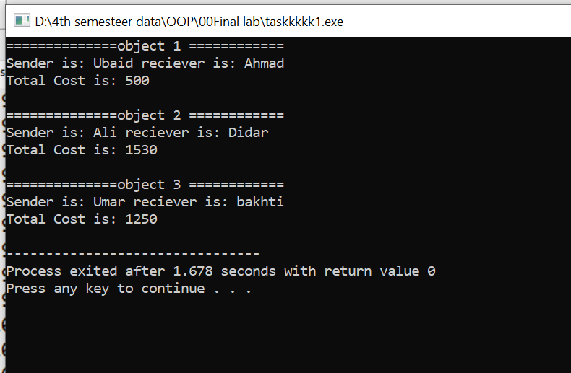

TASK 2
CODE:
#include <iostream>
using namespace std;

class Device {
protected:
string name;
float power;

public:
Device() {
name = " ";
power = 0;
}
void getdata() {
cout << "Enter Device Name: ";
cin.ignore();
getline(cin, name);
cout << "Enter Device Power: ";
cin >> power;
}

void putdata() {
cout << "Device Name is: " << name << endl;
cout << "Device Power is: " << power << endl;
}

virtual bool isOverload() = 0;
};

class TrafficStat {
protected:
float first_month_data;
float second_month_data;
float third_month_data;

public:
TrafficStat() {
first_month_data = 0;
second_month_data = 0;
third_month_data = 0;
}

void getMonthsData() {
cout << "Enter first month data: ";
cin >> first_month_data;
cout << "Enter 2nd month data: ";
cin >> second_month_data;
cout << "Enter 3rd month data: ";
cin >> third_month_data;
}

void display_monthly_data() {
cout << "first month data is: " << first_month_data << endl;
cout << "second month data is: " << second_month_data << endl;
cout << "third month data is: " << third_month_data << endl;
}
};

class Router : public Device, public TrafficStat {
int max_connections;

public:
Router() {
max_connections = 0;
}

void getdata() {
Device::getdata();
cout << "Enter maximum Connections: ";
cin >> max_connections;
getMonthsData();
}

void putdata() {
Device::putdata();
cout << "Maximum Connections are: " << max_connections << endl;
display_monthly_data();
}

bool isOverload() override {
return max_connections > 1000;
}
};

class Switch : public Device {
int port_count;

public:
Switch() {
port_count = 0;
}

void getdata() {
Device::getdata();
cout << "Enter port_count: ";
cin >> port_count;
}

void putdata() {
Device::putdata();
cout << "port_count is: " << port_count << endl;
}

bool isOverload() override {
return port_count > 48;
}
};

int main() {
Device* d[6];

d[0] = new Router();
d[1] = new Router();
d[2] = new Router();

d[3] = new Switch();
d[4] = new Switch();
d[5] = new Switch();

for (int i = 0; i < 6; i++) {
cout<<"---Object :"<<i+1<<endl;
d[i]->getdata();
}

cout << "\n" << endl;

for (int i = 0; i < 6; i++) {
d[i]->putdata();
}

cout << "checking overload function for routers" << endl;
for (int i = 0; i < 3; i++) {
cout << "router " << i + 1 << ": " << d[i]->isOverload() << endl;
}

cout << "checking overload function for switches" << endl;
for (int i = 3; i < 6; i++) {
cout << "switch " << i - 2 << ": " << d[i]->isOverload() << endl;
}

for (int i = 0; i < 6; i++) {
delete d[i];
}

return 0;
}
OUTPUT:
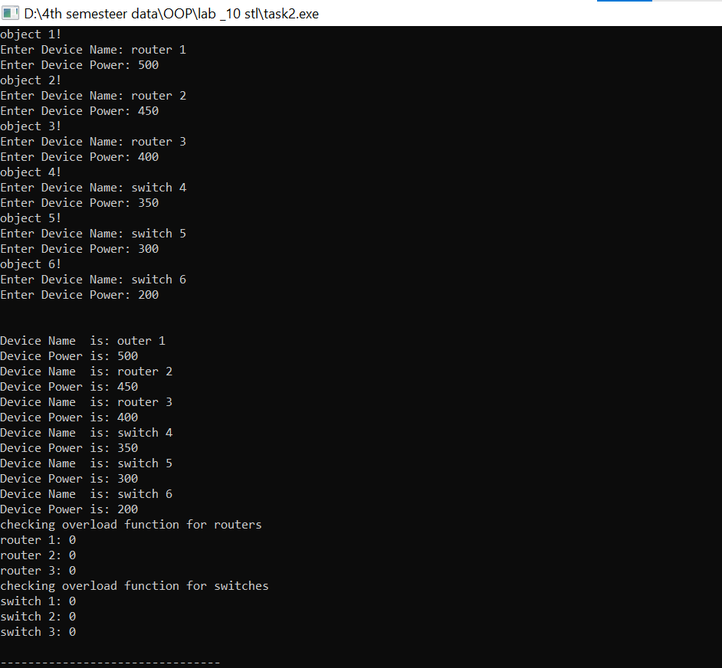
END,,,

